CMAP
233 SOUTH WACKER DRIVE, SUITE 800
CHICAGO, IL 60606

2 LBS 1 0F 1

Ship to:

the Freight- Manufacturing Nexus: Metropolitan Chicago’s Built-in Advantage

August 2013

CMAP NEXT DAY AIR
TRACK #FY14-00000

August 2013

Table of Contents
The Freight-Manufacturing Nexus: Metropolitan Chicago’s Built-In Advantage 2
Section I. Freight-Manufacturing Nexus Drives Recent Regional Economic Growth 3
Section II. Economic Advantages of Co-Location: How a Concentration in Freight Supports Regional Manufacturing Competitiveness 6
How Co-Location Supports Regional Economic Growth 11
Section III. What Types of Manufacturing Benefit Most from Freight Co-Location? 14
Varying Degrees of Regional Freight and Manufacturing Co-Location 14
Co-Location by Manufacturing Type 15
Sub-Clusters in Metropolitan Chicago 20
Conclusion 23

The Freight-Manufacturing Nexus: Metropolitan Chicago’s Built-In Advantage
Metropolitan Chicago is one of the nation’s few truly global centers of commerce. With a gross regional product of over $500 billion a year, the region’s dynamic economy ranks third largest in the U.S. Indeed, metropolitan Chicago’s economic output not only outperforms other regions but also surpasses that of many nations; if our region were counted as its own country, it would have the 20th largest economy in the world.1

While the region enjoys a diverse mix of industries across almost every sector, it also realizes significant gains through its economic specializations. Historically the region’s most pronounced concentrations have been in freight and manufacturing. Together these two industries have helped transform Chicago from an isolated outpost into a bustling global region. Massive investments in transportation infrastructure positioned metropolitan Chicago as the conduit for raw materials fueling an industrializing country, and the region’s own manufacturing capacity developed in turn. By the 20th Century these investments had rooted metropolitan Chicago at the core of the world’s leading industrial belt and the center of a massive transcontinental freight system.

Although the conditions that fueled early growth in the region have changed, CMAP’s recent cluster drill-down reports2 show how specialization in freight and manufacturing is no less important in today’s global economy, challenging the view that globalization will inevitably lead to a "post-industrial" society in the U.S. Indeed, ever-expanding global trade serves to augment the importance of regional freight and manufacturing, as more goods that improve the welfare of residents and businesses flow into the region and more final products are exported to an increasingly global consumer class.

The region’s freight-manufacturing intersection is metropolitan Chicago’s built-in advantage to adapt to a changing global economy. In particular, the size and strength of metropolitan Chicago’s freight cluster makes the region uniquely positioned and equipped to capitalize on the recent resurgence in U.S. manufacturing. These past freight investments—not only in transportation infrastructure but also in workforce and process innovations—continue to facilitate the manufacturing process in metropolitan Chicago. This paper explores the concept of a Freight-Manufacturing Nexus, where unique regional infrastructure and specialization in both freight and manufacturing combine to add significant value to the production processes.
Furthermore, the paper explores why compared to other domestic regions this concentration and unparalleled freight access means metropolitan Chicago is poised to translate recent manufacturing momentum into regional economic growth.

This paper is organized in three sections. The first section describes the components of the freight-manufacturing nexus and documents how the nexus is driving economic growth in the

1 World Business Chicago, “A Plan for Economic Growth and Jobs,” 2012, p.13.
2 See “Metropolitan Chicago’s Freight Cluster: A Drill-Down Report on Infrastructure, Innovation and Workforce,” http://www.cmap.illinois.gov/policy/drill-downs/freight and “Metropolitan Chicago’s Manufacturing Cluster: A Drill-Down Report on Innovation, Workforce and Infrastructure,” http://www.cmap.illinois.gov/policy/drill- downs/manufacturing.

region. The second section explains the economic advantages of freight and manufacturing co- location and how the region’s unparalleled freight system and sophisticated logistics operations boost accessibility and lower costs for regional manufacturers. The third section analyzes how the regional tendency to co-locate freight and manufacturing depends to an extent on the varying freight needs of specific manufacturing industries.

Section I. Freight-Manufacturing Nexus Drives Recent Regional Economic Growth

What is the Freight-Manufacturing Nexus?
To better understand how the region’s dual concentration relates to a changing global economy, CMAP created the Freight-Manufacturing Nexus as a unit of analysis. CMAP’s nexus describes how a concentration in freight supports substantial regional manufacturing productivity by examining those industries directly enabling and contributing to the region’s industrial value- add. On the freight side this includes carriers that bring in raw materials and intermediate inputs, enable intraregional supply chains, and provide access for final goods through local consumption and exporting. It also includes logistic services provided to freight carriers and manufacturers, an increasingly indispensable element in an era of global supply chains and just- in-time production.

With this concentration of freight carriers and logistics firms, regional manufacturers can better develop supply chains, realize cost savings and efficiencies, optimize distribution and inventory, and exploit comparative advantage. In short, the regional concentration and co- location of freight and manufacturing provides rooted economic benefits.

The Three Core Industries of Metropolitan Chicago’s Freight-Manufacturing Nexus
Industry | Regional Employment (2012) | Regional Concentration  Measure (2012 LQ)*
Manufacturing | 388,105 | 1.1
Freight Carriers | 82,517 | 1.27
Logistics | 21,301 | 2.0
*A location quotient (LQ) above one indicates industries where metropolitan Chicago is more specialized compared to the national average. All data for the 7-county CMAP region.
Source: CMAP analysis of EMSI Complete Employment data, 2013.

Figure 1. Freight-manufacturing nexus
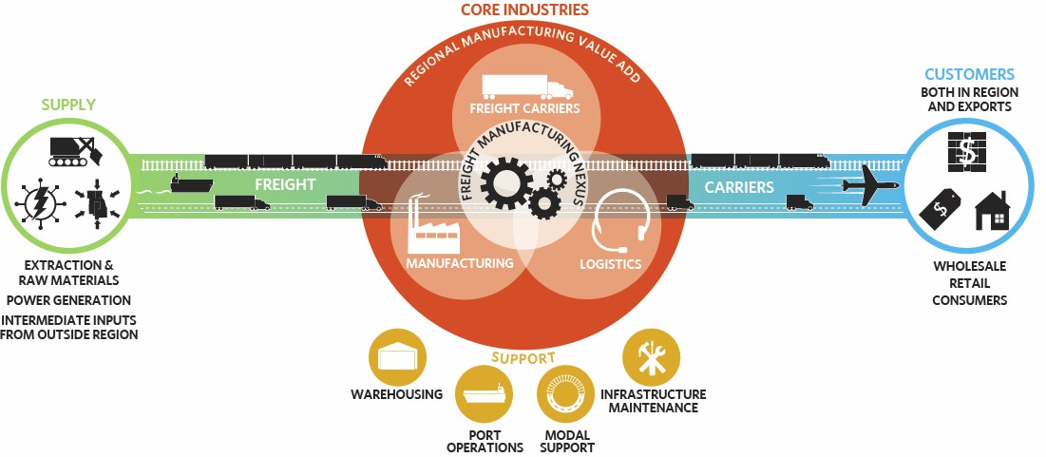
The freight-manufacturing nexus (in the center, within the red circle) consists of three core industries— manufacturing firms, freight carriers, and logistics providers—that together enable regional value-add in the manufacturing process. These core nexus industries are responsible for transforming inputs from supply industries (on the left, in green) into goods consumed by customer industries (on the right, in blue). Lastly, support industries (below the core, in yellow) provide essential services to the core.

Source: CMAP analysis, 2013.

Freight-Manufacturing Nexus Leads Metropolitan Chicago’s Economic Recovery CMAP’s cluster drill-down reports document recent momentum around freight and manufacturing as the economy rebounds from recession and global changes lead to renewed investments in domestic industry. Recent employment data quantify this momentum in the Chicago region: since 2010 employment in the region’s core freight-manufacturing nexus has grown by seven percent, over double the growth rate in the
In the past two years, employment in the region’s freight- manufacturing nexus has increased by seven percent, more than double the rate of the rest of the regional economy.
rest of the regional economy (2.8 percent).3 While the core nexus industries account for about ten percent of the region’s total employment, they were responsible for over 20 percent of all the region’s jobs created the past two years.

Not only has recent employment growth in metropolitan Chicago’s freight-manufacturing nexus outpaced other sectors, it also has grown faster than the respective national growth rate in the same freight, manufacturing, and logistics industries. Thus expansion in metropolitan Chicago’s freight-manufacturing nexus cannot simply be attributed to national trends. Instead this growth reflects the region’s existing advantages.

3 CMAP analysis of EMSI Complete Employment data, 2013.

Figure 2. Employment growth in regional freight-manufacturing nexus, 2010-12
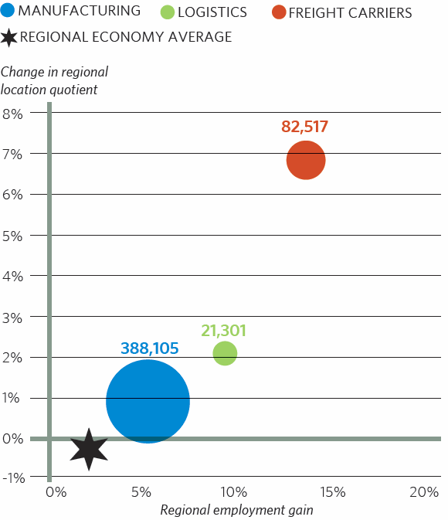

In this graph, circle size is proportional to current employment in each core industry. The horizontal axis measures regional employment growth by industry between 2010 and 2012. The vertical axis measures change in location quotients (LQ) to show how metropolitan Chicago’s growth compares to the rest of the nation. Each of the core industries posted a positive change in location quotient, indicating that metropolitan Chicago’s freight-manufacturing nexus industries have grown faster than the national average for those same industries. The six-pointed star measures employment change in the rest of the regional economy. Its slower growth rate and slight decrease in location quotient means the rest of the regional economy is not growing quite as fast as the national rate, underscoring how metropolitan Chicago’s economic rebound has relied disproportionately on growth in the freight-manufacturing nexus.

Source: Chicago Metropolitan Agency for Planning analysis of EMSI Complete Employment data, 2013. Note: Total number of workers included in regional economy average excluding nexus equal 4,524,863.

Section II. Economic Advantages of Co-Location: How a Concentration in Freight Supports Regional Manufacturing Competitiveness
Freight and transportation costs greatly affect manufacturing competitiveness. Recent research shows that raising transport costs by ten percent reduces trade volumes by twenty percent.4 In addition to just cost, freight can also affect manufacturers’ time to market, reliability, and flexibility in response to changing demands. As each step in manufacturing’s extensive value chain relies on freight, rising global trade has led to “a growing level of embeddedness” between complex manufacturing operations and the synchronized freight and sophisticated logistics needed to distribute the results of this production.5 This interdependence has emerged “as the foundation of the economic life of regions and firms.”6

Unlike many other peer regions, metropolitan Chicago already has an embedded and robust foundation in this freight-manufacturing intersection. This includes a singular combination of jobs and firms as well as supporting transportation infrastructure. On the infrastructure side these transportation assets include:

- Rail: Metropolitan Chicago is the only region served by six of the seven Class I railroads
- Truck: Seven major interstate highways converge in the region, the most in the nation
- Air: O’Hare is the nation’s second busiest international air cargo gateway by value (and Chicago/Rockford International Airport ranks 19th nationally for air cargo by weight)
- Water: The region’s water system serves as the only connection between the Mississippi River waterway and the Great Lake and Saint Lawrence Seaway system

Given new global market dynamics such as rising wages in China and reduced domestic energy costs, more and more firms will look to reinvest and expand certain types of manufacturing operations in the U.S.7 This section explores how metropolitan Chicago’s unique specialization in freight translates into economic benefits for regional manufacturing firms—the region’s freight system provides choice, impacts time, enhances market accessibility, improves logistics, and ultimately reduces costs, allowing regional manufacturers to focus on and better exploit their own comparative advantage to improve economic performance. Each of these advantages is explored in turn.

4 Jean-Paul Rodrigue et al., The Geography of Transport Systems, Hofstra University, 2012.
5 Ibid.
6 Ibid.
7 Chicago Metropolitan Agency for Planning, “Metropolitan Chicago’s Manufacturing Cluster: A Drill-Down Report on Innovation, Workforce, and Infrastructure,” February 2013.

Mode Choice
First, the Chicago region has unrivaled multi-modal freight infrastructure; few areas can emulate our region’s capabilities across every freight mode. Each freight mode provides distinct cost, speed, and other performance options for manufacturers. For example, the chart on the following page illustrates how air freight offers improved speed and other performance measures, yet also has the highest costs of all the modes.
Water freight sits on the other extreme, with much lower costs yet also slower transport times. Unlike other regions, manufacturing firms in metropolitan Chicago are not tied to a single way of moving goods, but instead can select across all modes for a tailored freight option. This access to every major transportation type lets manufacturers pick a freight mode that fits their individual needs for time to market, cost, and flexibility.

Travel Time
In addition to mode choice, the region’s existing freight system can grant time

Figure 3. Regional cereal grains movements by mode
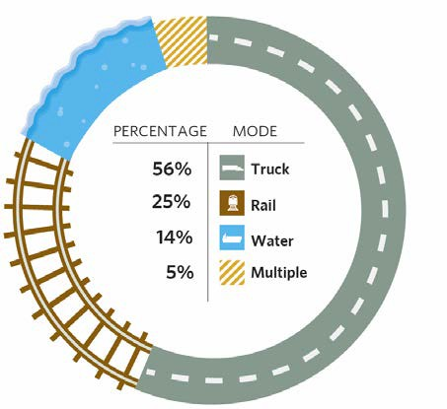

Manufacturers in metropolitan Chicago have unrivaled access to every freight mode, enabling firms to tailor freight moves to specific firm needs. For example, this graphic shows the variety of ways that regional food manufacturers source cereal grain inputs.

Source: Chicago Metropolitan Agency for Planning analysis of Freight Analyst Framework v3, 2007.

savings in goods movement. The national freight system converges on metropolitan Chicago, with more major interstates and railroads than anywhere else in the nation, as well as developed water and air freight facilities. Additionally, the demand generated as the nation’s second largest manufacturing cluster and third largest metropolitan area leads to more direct routes, frequent headways, and fewer layovers on routes serving the metropolitan area, which can result in reduced travel times getting to the region. Yet the flip side of concentrated infrastructure and demand is congestion, and metropolitan Chicago remains one of the most congested regions in the U.S. This paper’s conclusion raises how growing congestion threatens to undermine the transportation advantages enjoyed by regional manufacturers.

Figure 4. Cost to performance relationships for inland freight modes
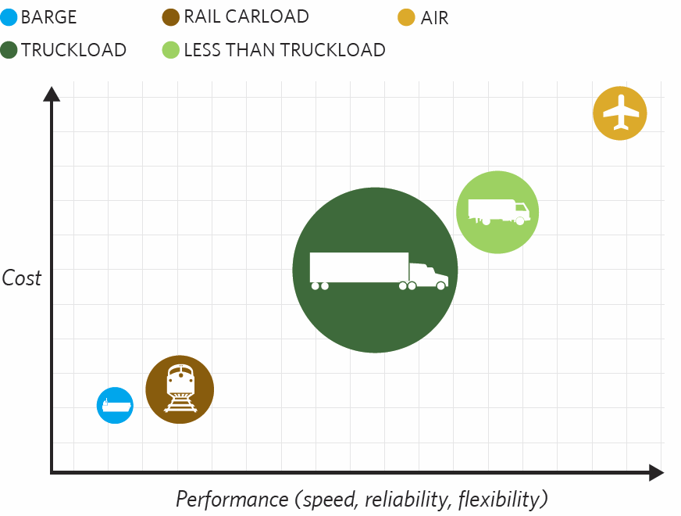

Source: Rodrigue, J-P et al., The Geography of Transport Systems, Hofstra University, 2012. Note: Approximate representations of cost and performance.

Supplier and Market Accessibility
Even more than time benefits from direct transport, the region’s confluence of transportation modes, firms, and infrastructure allows manufacturing firms to source inputs and sell products to virtually every market in the world. For inputs this includes specialized suppliers serving in niche markets as well as access to lower cost options, allowing regional firms to focus on their own comparative advantage. And the region’s freight system connects this value-added output of metropolitan Chicago’s manufacturing sector to global consumers. In 2010 metropolitan Chicago’s manufacturing cluster utilized the regional freight system to export abroad over $34 billion in manufactured goods, more than any domestic region except Los Angeles. These statistics only capture the value of international shipments, but metropolitan Chicago also exported billions more of manufactured goods to other areas within the U.S.8

Airports and intermodal terminals in particular increase accessibility for exporting firms, and metropolitan Chicago’s existing infrastructure provides numerous connections to domestic and global markets—O’Hare is the nation’s second busiest international air cargo gateway by value, and metropolitan Chicago’s intermodal terminals handle up to half of all rail container movements in the U.S.9 Metropolitan Chicago has a similar concentration in companies that

8 CMAP Manufacturing Drill-Down, 2013, p. 107.
9 CMAP Freight Cluster Drill-Down, 2012.

support regional export moves, with over 14,000 full-time equivalent positions in rail transportation and 38,000 in long distance trucking. In both these industries the region maintains a striking specialization, with a LQ of 2.18 in rail and 1.27 in long distance trucking. For air moves the region remains slightly specialized, in both air freight transport (LQ 1.09) and airport operations (LQ of 1.19).10

While the region’s freight system connects metropolitan Chicago to the world, it also provides invaluable links to regional supply chains. Regional production systems continue to play an integral role in the global economy, and the average distance for manufacturing-related truck trips in metropolitan Chicago is only 59 miles.11 Unlike inbound and outbound freight flows that tend to use multiple freight modes, short haul trucking moves the vast majority of all intraregional freight in metropolitan areas (for example, 97 percent in Los Angeles, 98 percent in Chicago, and 99 percent in New York).12 With over 19,000 positions and a location quotient of
1.54 metropolitan Chicago is highly specialized in this general short haul trucking that connects regional manufacturing nodes.13 The high location quotient means that compared to other areas, manufacturers in metropolitan Chicago have much more accessibility and choice in finding a local supply chain trucker to meet specific cost, time, and flexibility needs and to better connect specialized suppliers within regional supply chains.

Improved Logistics
By percentage, logistics is the fastest growing segment of the nexus. Between 2002 and 2012 logistics firms in metropolitan Chicago added over 5,600 jobs, growing at a rate of 36 percent. In that same period the region increased its logistics specialization relative to the national average, with the regional location quotient in logistics employment increasing from 1.86 to 2.14

A concentration in logistics augments transportation advantages by more efficient and coordinated freight movement. Across all types of moves regional manufacturers can draw on metropolitan Chicago’s specialized and growing logistics industry to better organize supply chains. In particular, the region’s high concentration of logistics firms improves reliability, an essential element in today’s economy as more manufacturers operate under just-in-time production models. Indeed, two recent surveys—one international and one national—found that manufacturers’ top freight concern was not cost but reliability.15 With a growing concentration logistics providers can help manufacturers better capitalize on the region’s agglomerated freight assets to improve reliability, by meeting tight supply chain windows, identifying alternatives if something goes wrong, and providing a more constant and predictable level of demand.

10 CMAP analysis of EMSI Complete Employment data, 2013.
11Glen Weisbrod, Donald Vary, and George Treyz, “Economic Impacts of Congestion,” National Cooperative Highway Research Program Report #463, Transportation Research Board, 2001.
12 CMAP analysis of FAF v3, 2007. Excludes freight moving via pipelines.
13 CMAP analysis of EMSI Complete Employment data, 2013.
14 Ibid.
15 Linda M. Taylor, “A Deadly Sin,” Electronics Supply and Manufacturing, April 2006, and John Vickerman, “Rail Delivers Jobs and Drives Economic Development,” The Rail Summit hosted by Lakeshore Chamber of Commerce, Chesterton, IN, March 16, 2012.

CMAP’s freight cluster drill-down report noted that logistics firms rely heavily on skilled workers, and increased technological adoption in logistics serves as a growing competitive edge for metropolitan Chicago. For example, system software
“Innovation and its deployment does not happen just anywhere. It happens in places, most notably, within metropolitan regions, where firms and workers tend to cluster in close geographic proximity, whether to tap local supplier networks, draw on local workers, or profit from formal knowledge transfer.” - Mark Muro and Jessica Lee¹⁶
developers within logistics grew by 106 percent in the region this last decade while network and computer systems administrators grew by 85 percent.17 Regional manufacturers stand to benefit as more local logistics firms continue to build off rapidly evolving technology through improved route optimization, a more nimble response to ever-changing market demands and customer needs, and other tools to better run the supply chains that support manufacturing’s value- adding process.

Cost Improvements
The accessibility, speed, choice, and reliability provided by metropolitan Chicago’s concentrated freight system leads to cost performance advantages for regional manufacturers. More access compels increased competition among upstream suppliers, resulting in lower prices for downstream firms. More direct routes reduce lost fuel and time, while mode choice offers more price options for firms. One of the many ways logistics firms can reduce costs is through a more efficient use of inventory levels. Firms accrue costs from carrying extra inventory, such as the additional labor and warehouse space to manage, hold, and monitor the stock as well as depreciation and lost market share from changing consumer demand. For example, an additional seven days of inventory for Nike’s domestic operations costs the company an extra $4 million per week.18 With enhanced logistics, manufacturers can better manage inventory levels and benefit from lean production models that have helped keep down costs and improve firm profitability.

Perhaps the most substantial cost benefit comes from the region’s co-located concentration of demand—metropolitan Chicago is the nation’s second largest freight cluster as well as the second largest manufacturing cluster. This dual concentration provides cost benefits because carriers coming into the region are more likely to carry at full capacity or combine small loads into full conveyance (which is more profitable since operator wages don’t change given load capacity and fuel consumption only increases marginally), and importantly, find a load for the outbound trip (carriers only collect revenue for loaded moves yet often have to travel empty back to their point of origin). As such, carriers charge at lower rates to move freight into agglomerated clusters like the Chicago region.19

16 Mark Muro and Jessica Lee, “Hubs of Manufacturing: Let’s Get Started,” Up Front Blog, Brookings Institution, August 20, 2012.
17 CMAP analysis of EMSI Complete Employment data, 2013.
18 “The Economic Costs of Freight Transportation,” U.S. Department of Transportation, Federal Highway Administration, http://ops.fhwa.dot.gov/freight/freight_analysis/freight_story/costs.htm.
19 Yossi Sheffi, “Logistics-Intensive Clusters: Global Competitiveness and Regional Growth,” 2010, p. 19.

Figure 5. Freight's tangible economic benefits for manufacturers
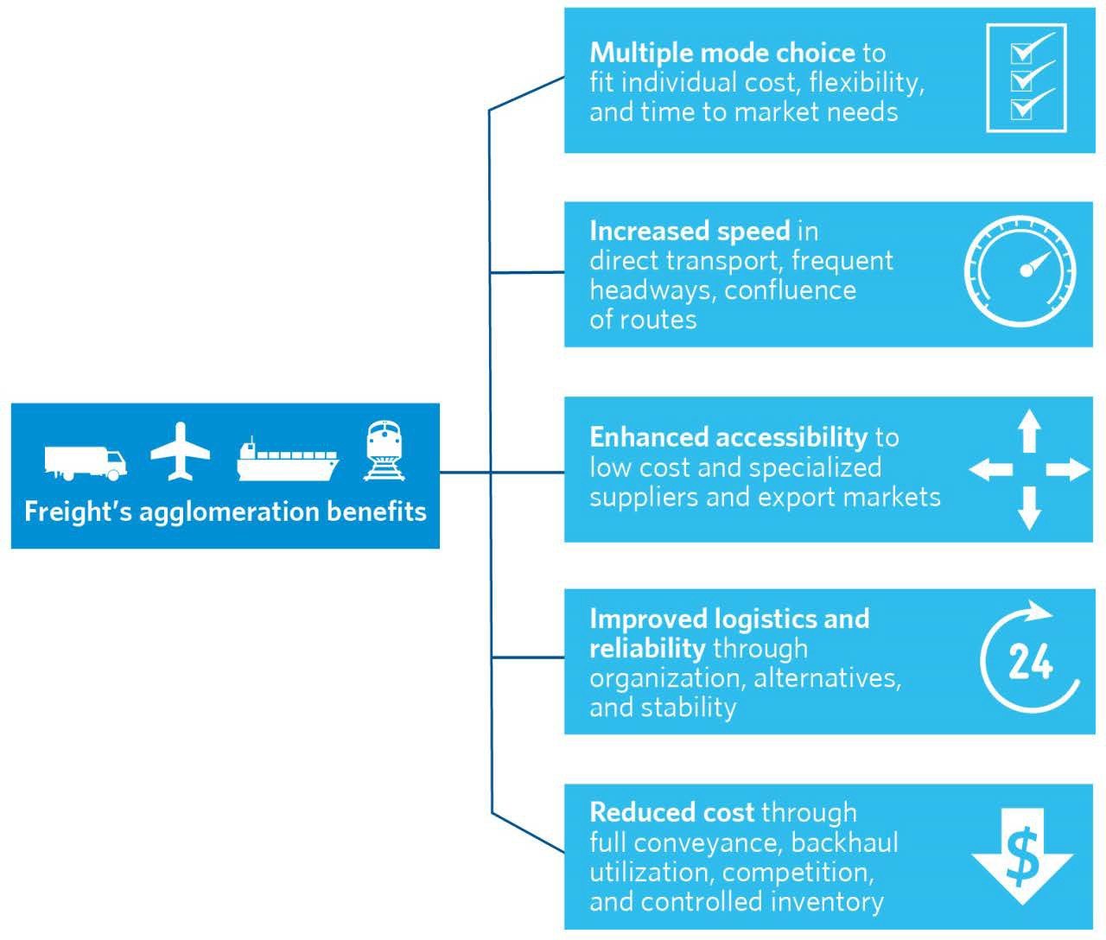
Source: Chicago Metropolitan Agency for Planning, 2013.

How Co-Location Supports Regional Economic Growth
The economic advantages discussed above translate into every segment of the manufacturing process, from sourcing inputs to developing supply chains to exporting the results of value- added production. For example, the region’s concentration of freight firms and infrastructure better supplies regional manufacturers with raw materials and intermediate inputs that form the basis of regional manufacturing, as well as the fuel sources to power their transformation. Because of this incoming supply, manufacturing production does not have to be tied to the place of resource extraction, instead enabling the region to compete through other factors of production.

The most pronounced impact of metropolitan Chicago’s manufacturing and freight co-location comes from its contribution to the regional value added in manufacturing. While today’s supply chains stretch across the globe, many value-adding manufacturing activities are still tied to regional production systems: by weight, half of all manufactured goods movements in the U.S. are less than 50 miles, illustrating the importance of regional supply chains.20 A study on metropolitan Chicago confirms the centrality of regional manufacturing supply chains, where

20 CMAP Manufacturing Cluster Drill-Down, 2013, p. 35.

the average distance for manufacturing-related truck trips was 59 miles.21 And unlike flows of inbound raw materials (whose value comes primarily from extraction occurring outside the region) or manufactured imports (whose value is the result of competing manufacturing regions), these local freight moves in regional production systems are essential to metropolitan Chicago’s economy since the value-add occurs within the region. The results of this regional production system fuels economic growth—metropolitan Chicago’s manufacturing sector contributes over $65 billion each year to gross regional product, more than all but one other sector.22

The region’s co-location of freight firms in proximity to manufacturing helps improve regional value-add in manufacturing through specialization and division of labor. In the past, much of manufacturing was vertically integrated, meaning the production process was centrally controlled from raw materials to final assembly. For example, Ford Motor Company’s colossal River Rouge Complex turned raw materials into running vehicles under a single roof. Yet in response to global competition many manufacturing companies have come to focus not on the entire production process but instead on their core (and most profitable) competency. A result of this division of labor is that American manufacturing firms today are on average smaller, tending to specialize in a specific component of a final good.23 These smaller specialized firms tend to cluster regionally; indeed, 84 percent of all manufacturing cluster firms in metropolitan Chicago employ 50 workers or fewer.24 This co-location produces numerous supply chain moves within metropolitan areas and thus the need for an efficient intraregional freight system to connect this type of manufacturing that grows the regional economy.

Metropolitan Chicago’s primary metal, to metal fabrication, to final machinery supply chain exemplifies how freight and manufacturing co-location enables impressive regional industrial output. Unlike lower weight, higher value goods such as electronics that tend to utilize a global production system, trade flows in heavier and capital-intensive industries like metalworking and machinery are still “dominated by regional transport systems integrated into regional production systems.”25 This pattern of heavy and capital-intensive industries utilizing regional supply chains hold in metropolitan Chicago as well, where a greater proportion of the nearly 300 million tons of freight moving within the region each year are in primary metals, minerals, and metal fabrication.26

21Weisbrod et al., “Economic Impacts of Congestion.” National Cooperative Highway Research Program Report #463, Transportation Research Board, 2001. This is noteworthy in that the 59 mile average combines local moves with long- distance truck trips into and out of the region, showing how many smaller regional moves balance out fewer long- distance moves (indeed, the average distance for manufacturing truck trips just within metropolitan Chicago was 11 miles).
22 CMAP Manufacturing Cluster Drill-Down, 2013, p.3.
23 MIT Taskforce on Innovation and Production, “A Preview of the MIT Production in the Innovation Economy Report, Massachusetts Institute of Technology, 2013.
24 CMAP Manufacturing Cluster Drill-Down, 2013, p. 68.
25 Jean-Paul Rodrigue et al., The Geography of Transport Systems, 2012, section 4-8.
26 CMAP analysis of FAF v3, 2007.

Figure 6. Freight enables value added in regional manufacturing
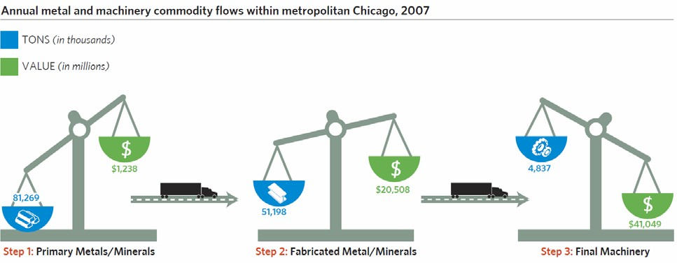

This graphic depicts the intraregional primary metal to machinery supply chain, with the scales a figurative portrayal of the shift from high weight to high value goods. In the first step, heavy and relatively low value primary metal products move through the region, becoming inputs in the second step for regional fabricators to create more valuable semi-finished goods and discrete parts. Original equipment manufacturers then assemble these intermediate inputs into high value machinery. Freight —
represented by the truck symbol — provides the link between these steps, illustrating how the region’s value added in manufacturing supply chains is contingent on access to freight firms and infrastructure.

Source: Chicago Metropolitan Agency for Planning analysis of Freight Analyst Framework v3, 2007.

Compared to the import of products manufactured elsewhere, the results of this intraregional supply chain and corresponding freight moves provide substantial economic benefits that stay within the Chicago region. One of these economic benefits comes from manufacturing’s tradability. While sectors such as health, education, or retail deliver essential services, their output is largely tied to local consumption, which can feasibly support only so many hospitals or shopping malls. In contrast, regional manufacturing is an export-oriented industry and through a co-location with freight its output can be traded across the globe. These manufacturing exports bring in billions of new dollars that otherwise wouldn’t be captured within metropolitan Chicago, such as the $11 billion coming just from international machinery exports in 2010, a 50 percent increase from inflation-adjusted 2003 levels.27

27 CMAP Manufacturing Drill-Down, 2013, p. 108.

Section III. What Types of Manufacturing Benefit Most from Freight Co-Location?
The previous section described freight’s central role in the manufacturing process and how metropolitan Chicago’s unique concentration of transportation infrastructure and freight firms provides tangible economic benefits for regional manufacturers. Yet manufacturing in this region is highly diverse, and results in a wide variety of freight moves and demands on infrastructure. This final section of the report first explores the diverging degrees of freight and manufacturing co-location in the region, and then shows how the regional tendency to co-locate depends on the varying freight needs of specific manufacturing industries: Heavy production and regional processing industries tend to co-locate near freight firms and infrastructure to minimize transportation costs and maximize supply chain connections, while high value tradable goods draw less on immediate co-location, instead benefiting from reliability, flexibility, and export access.

Varying Degrees of Regional Freight and Manufacturing Co-Location
To understand the relationship between regional freight and manufacturing, CMAP analyzed core nexus industry employment by zip code.28 The map on the following page illustrates these results, and shows the region’s two largest centers of manufacturing employment—the areas around O’Hare and Midway—also have the largest concentration of regional freight employment. These key nodes illustrate a strong propensity for regional freight and manufacturing co-location.

Not surprisingly, these two areas containing highly specialized freight and manufacturing employment occur in close proximity to highways, airports, intermodal terminals, and other transportation infrastructure. For example, the area north and west of O’Hare is well served by various transportation modes, such as the nation’s second busiest airport for international cargo, freight rail, and a confluence of interstates and arterials.

The second node that stands out for its high concentration in both freight and manufacturing employment—Chicago’s Southwest Side and parts of Southwestern suburban Cook County— loosely parallels I-55 out to La Grange and Bedford Park. This area lies at the historic center of the region’s rail system and contains the region’s largest concentration of intermodal facilities. Through the Chicago Sanitary and Ship Canal this node also has access to water freight, though overall water freight is a much smaller portion of the regional freight system.

While the nodes around O’Hare and Midway airports showcase prominent nexus co-location, the map below also illustrates areas in the region where freight and manufacturing do not always cluster together. For instance, southern Lake County near the I-294/I-94 split has high manufacturing employment yet lacks a corresponding concentration in freight. Conversely, areas like southern Will County have higher freight concentrations but less manufacturing. The next section explores how this mixed level of freight and manufacturing co-location seems to stem from the type of manufacturing activity.

28 All conclusions regarding industry and firm location and employment in this section are based on CMAP analysis of April 2013 Dun and Bradstreet data.

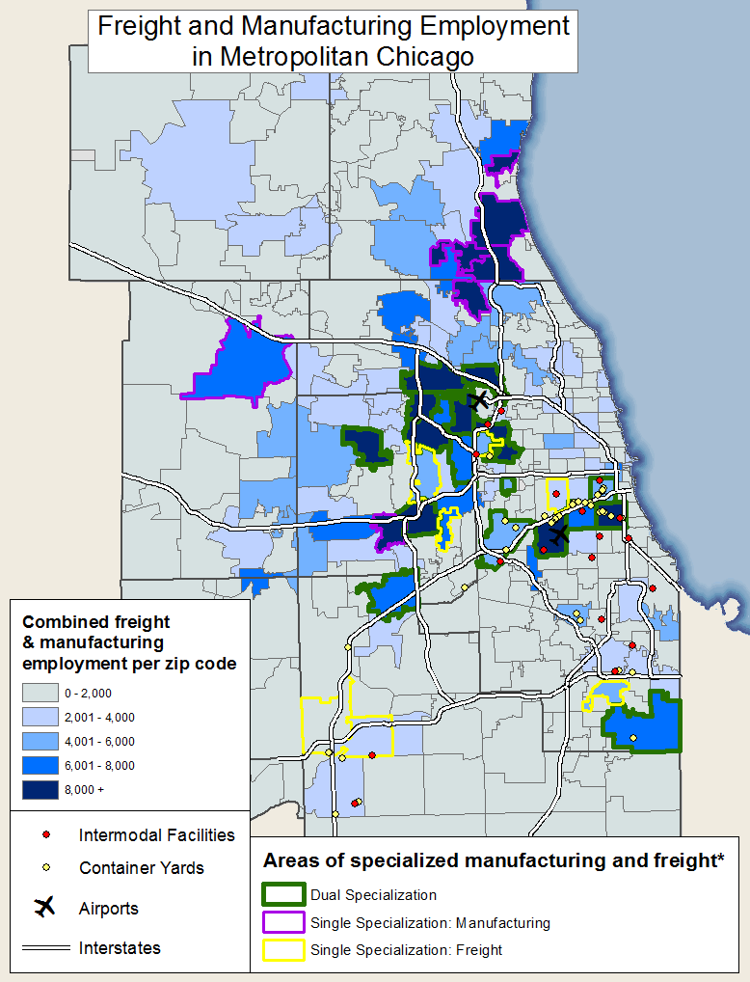

*Dual specialization includes those zip codes that have concentration in both freight and manufacturing employment, while areas of single specialization have a concentration in either freight or manufacturing employment but are below the mean for employment in the other half of the nexus.

Source: CMAP analysis, 2013.

Co-Location by Manufacturing Type
Metropolitan Chicago’s diverse manufacturing composition serves as a hallmark of the cluster. To organize this varied industrial concentration, CMAP developed three broad manufacturing categories—resource-intensive primary production, regional processing, and globally traded

final goods—based off our cluster drill-down report and recent work from the McKinsey Company.29 The table below analyzes value and weight of goods movement, major transportation characteristics and determinants, and freight modes across each of the three groupings to help explain what industries benefit most from immediate co-location with freight firms and infrastructure. The paragraphs that follow synthesize the results for each manufacturing category.

Freight Needs Across Manufacturing Type
Resource-Intensive Primary Production |  | Regional Processing | Globally Traded Final Goods
Value density* | Low | Medium | High
 |  | Regional Consumption: | Labor Intensive:
 | -Less product variation so | -Freshness, local tastes | -Lower wages paramount
 | compete on price | -Time to market | over transportation costs
Major | -Commodity price volatility a | Intermediate Parts:  -Upstream (raw material suppliers) and downstream (customer) connections  -Vertical disintegration,  specialization, customization | Innovative Leaders:  -Just-in-time production  -Rapid response to changing consumer demand  -Skilled workforce
transportation | factor
characteristics | -Look to squeeze out cost
 | advantage through
 | transportation
 |  | Regional Consumption: | Labor Intensive:
 |  | -Food | -Furniture
 | -Wood | -Beverage | -Apparel
 | -Petroleum and coal | -Printing | -Some electronics
Industries | -Paper | Intermediate Parts:  -Fabricated metals  -Plastics and rubber  -Chemicals | Innovative Leaders:  -Medical supply  -Machinery  -Some computer and  electronics
 | -Primary metals
 | -Waste
Key transportation  determinants | Transportation costs and proximity | Supply chain connections | Reliability, flexibility, export access
Major freight modes | Truck, rail, water | Truck | Truck, air
Tendency to co- location with  freight | High | High | Mid to Low
*Value density is the value of the shipment divided by its weight

Source: CMAP analysis, 2013.

29 McKinsey Company, “Manufacturing the future: The next era of global growth and innovation,” November 2012.

Resource-Intensive Primary Production Industries
Manufacturing Industries:
- Wood and Paper
- Petroleum and Coal
- Primary Metals and Minerals

This first grouping comprises manufacturing industries that turn the results of natural resource extraction into primary manufactured materials. For example, the wood industry transforms forest output into lumber that can then be used in furniture, building trades, or other final manufacturing while the primary metals industry converts the results of mining into iron or steel to be used in machinery and countless other manufacturing sectors. The industries comprising this grouping have the lowest value density of shipments (which is the value of the shipment divided by its weight) of any manufacturing industry, ranging from just $118 per ton in primary minerals to $1,250 in primary metals. As the chart below shows, this low value density serves as the key freight hallmark of this grouping—compared to other types of manufacturing, freight moves by industries in the primary production group involve extremely heavy and relatively lower value goods.

Figure 7. Value of shipments per ton in manufacturing industries, 2012
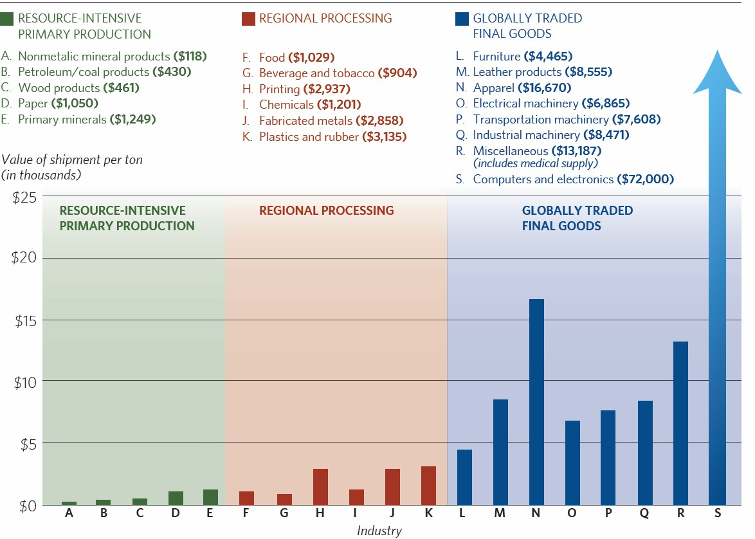
Source: Adapted from Wial et al., “Why Does Manufacturing Matter?” 2012.

Because of the heavy weight and lower value of unprocessed materials, which are often commodities sold at the same or similar cost per unit, input costs have more of an impact on manufacturing profitability in these industries compared to other types of manufacturing. For example, in the steel industry raw materials account for 70 to 80 percent of all costs, while in the petroleum industry this nears 85 percent, more than twice the rate of other manufacturing industries such as computers and electronics.30 Primary industries in this first grouping also require more energy to transform raw materials, where purchased fuel and electricity contribute between seven to 15 percent of value-add, compared to just four percent in all other manufacturing industries.31

With less product variation, firms in these resource-intensive industries compete primarily through price, and the heavy nature of raw material goods movement means much of that price is composed of transportation costs.32 As such, the cost of freight transportation serves as a primary factor of profitability in these manufacturing industries, and more so than other manufacturing types, wood, paper, petroleum and coal, and primary minerals and metal industries’ leading benefit from the freight system comes from cost advantages and proximity to heavy infrastructure such as rail sidings or water ports. As raw materials and primary commodities are often moved in bulk, these heavy industries tend to use more cost efficient freight modes such as rail and water in addition to trucking.33

Regional Processing Industries
Manufacturing Industries: Regional Consumption
  - Food and beverage
  - Printing Intermediate Parts
  - Fabricated metals
  - Plastics and rubber
  - Chemicals

The unifying theme of the regional processing grouping is freight accessibility to both up and downstream supply chains. Industries in this regional processing category tend to locate near both inputs (often coming from primary industries) and customers, either through local demand (such as food or printing) or as an intermediate input in value-adding regional manufacturing supply chains (such as fabricated metals). These regional processing industries contribute over half of all manufacturing jobs in metropolitan Chicago, underscoring their vital contribution to the economy.

The value density of regional processing industries is higher compared to resource-intensive primary industries, yet still much lower than globally traded final goods, meaning freight costs continue to be an important factor for this second industry grouping. Yet more so than the primary industries, regional processing industries also extract further benefits besides just cost from the region’s freight system. For regional consumption this includes time to market for both

30 CMAP analysis of U.S. Census Bureau, Annual Survey of Manufacturers, 2011.
31 McKinsey, “Manufacturing the future,” 2012.
32 Ibid.
33 CMAP analysis of Freight Analysts Framework, and McKinsey “Manufacturing the future.”

food and printing, as well as the flexibility to respond to changing local tastes. For intermediate inputs a leading freight benefit is supply chain connectivity, because these industries often serve as the value-adding link between material suppliers and final manufactured goods. To maximize supply chain connections these industries rely primarily on truck transport for goods movements within metropolitan regions.34

Globally Traded Final Goods
Manufacturing Industries: Innovation Leaders
  - Machinery
  - Medical supply
  - Some computers and electronics Labor Intensive
  - Furniture
  - Apparel
  - Some electronics assembly

Industries in the first two manufacturing groupings transform raw materials into primary goods, and primary goods into intermediate inputs and discrete parts. The globally traded final goods segment turns the results of the first two manufacturing segments into final consumer products. Tradability serves as the hallmark of this third grouping, meaning industries look to the freight system for export access to new markets and consumers.

Tradable finished products have by far the highest value density of any manufactured good, meaning these lighter and more valuable products are less likely to be tied to regional production systems and more likely to be moved longer distances. Transportation costs will still be important on the lower end of this category, in industries such as furniture (with a value of
$4,465 per ton) and machinery ($7,000 to $8,000 per ton). Yet on the upper end of the value density spectrum, industries such as apparel ($16,700) and computer and electronics ($72,000)35 will be less bounded by transportation costs. The high value density of these finished products means firms can source from around the world.

Though freight transportation costs have a more minor impact for these tradable industries compared to primary and processing manufacturing, it doesn’t mean the final grouping is independent of the freight system. Key freight benefits for this third grouping include export access, reliability, and flexibility. For example, manufacturers increasingly operate under just- in-time processes as a profit-maximizing strategy, with narrow transfer windows and tight supply chains of specialized suppliers. Tradable industries must react quickly to shifting consumer demand, which in turn requires a reliable freight response. And getting products more quickly to changing markets can be a competitive advantage for globally tradable products, so these industries tend to rely on the higher cost yet faster and better performing air and specialized truck modes.

34 CMAP analysis of Freight Analysts Framework, and McKinsey “Manufacturing the future.”
35 CMAP analysis of U.S. Census Bureau, Annual Survey of Manufacturers, 2011.

Sub-Clusters in Metropolitan Chicago
These three manufacturing categories suggest that while all types of manufacturing rely on the freight system, they do so in different ways. Heavy production and regional processing industries tend to co-locate with freight firms for cost and accessibility benefits. In contrast, higher value tradable goods are more likely to be tied into global production systems, so need less immediate co-location with regional freight firms.

The map and analysis below ties these findings to metropolitan Chicago by identifying where key industries in each of the resource-intensive primary production, regional processing, and globally traded categories concentrate in the region.36 Each industry shows a distinct geography and corresponding need from the regional freight system. These results help explain why the key nodes around O’Hare and Midway benefit from both freight and manufacturing employment while manufacturing concentrations in southern Lake County can operate with less freight co-location. In turn, the results also show what types of manufacturing best leverage the region’s unique status as a freight and manufacturing hub.

Primary metals—an example of the resource-intensive grouping—is the first of the five analyzed industries and has its strongest intensity37 in south suburban communities such as Harvey or Chicago Heights, with a secondary concentration anchored around the O’Hare submarket. This concentration grants manufacturers mode choice, such as access to water and rail freight as well as proximity to suppliers in northwest Indiana. This distribution supports the idea that transportation costs and infrastructure accessibility are key locational determinants in resource-intensive primary industries.38 Overall, the geographic concentration of primary metals suggests a strong incentive for the industry to locate in close proximity to and benefit from freight firms, infrastructure, and demand.

Like the resource-intensive primary production grouping, regional processing industries in the Chicago region also showcase a strong tendency to concentrate with freight firms and infrastructure. For example, fabricated metal firms are spread throughout the region yet maintain a striking concentration in the O’Hare submarket. The regional average for number of fabricated metal firms per zip code is about 10; the top zip codes near O’Hare have fifteen times that number.39 By concentrating at the core of the region’s freight-manufacturing nexus, fabricated metal firms reflect the advantages for intermediate part industries in locating near freight firms and infrastructure—co-location grants access to upstream material suppliers, downstream final equipment assemblers, and other supply chain connections.

While regional metal fabricators exhibit a particular concentration in the region’s freight- manufacturing node around O’Hare, food manufacturers have a striking concentration in the region’s second node: All of the top zip codes for number of food manufacturing firms lie in Chicago, with a contiguous concentration in the area northeast of Midway. At the heart of the region’s rail system, this location provides food manufacturers rail access to bring in bulk

36 As the map only presents five industries it is meant to be illustrative, not comprehensive, of the freight needs and co-location of regional manufacturers.
37 We use employment for primary metals because this industry is concentrated in a few, large factories. For the same reason we use employment for gear manufacturing, while for the other industries we use number of firms to gauge concentration.
38 McKinsey, “Manufacturing the future,” 2012, p. 53.
39 CMAP analysis of Dun and Bradstreet data, 2013.

agricultural products. By locating near freight carriers and demand it also helps ensure freshness and flexibility to meet local tastes.
The final manufacturing category looks at exportable manufactured goods. One industry where metropolitan Chicago maintains an export specialization is freight equipment manufacturing, in particular its freight drivetrain and transmission industry. The region’s export activity in this industry is evidenced by an extremely high 4.04 location quotient. As the map shows, this regional industry still seems to concentrate near freight assets—the higher weight and bulk of its output and position within a developed supply chain mean manufacturers likely seek to minimize transportation costs and maximize just-in-time production by locating in areas of freight and manufacturing co-location.

In contrast to heavier freight machinery, the region’s pharmaceutical exporters seem to rely less on immediate proximity to freight firms and infrastructure. Along with medical supply and electronics companies, these pharmaceutical firms comprise the majority of the region’s major manufacturing employment center in southern Lake County. The southern Lake County area stands out regionally because of its relatively smaller proportion of freight firms, and part of the explanation likely comes from the nature of the manufactured good. While these industries certainly need the regional freight system for export access, flexibility, and improved time to market, they may not depend as much on metropolitan Chicago’s status as a freight and transportation hub for future growth.

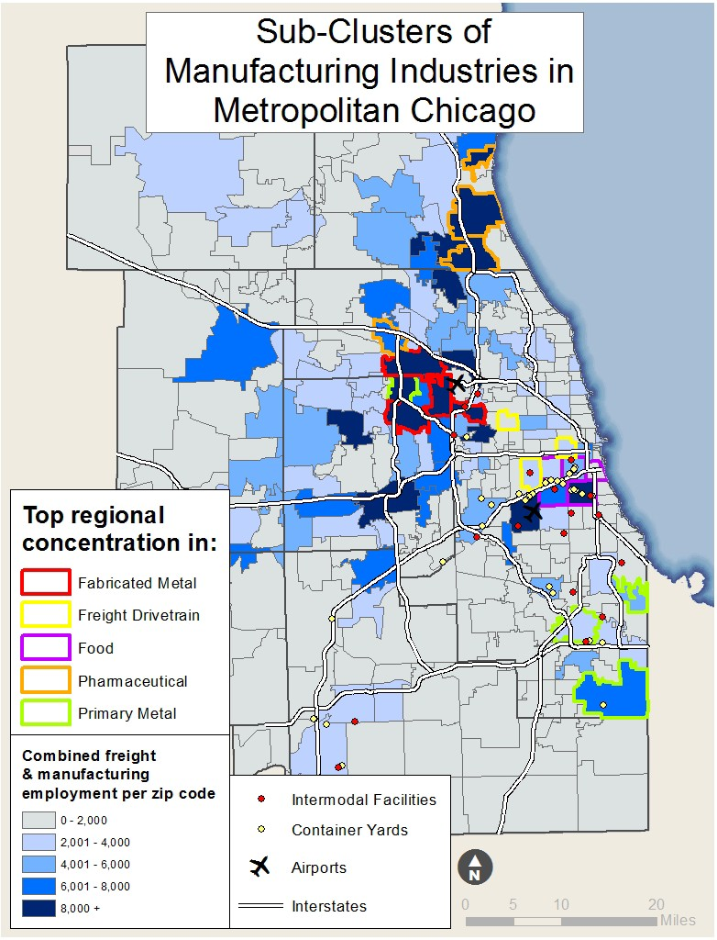

Source: CMAP analysis, 2013.

Note: The drivetrain connects the engine to the axles that moves the freight vehicle.

Conclusion
Few other domestic regions can emulate the scale and scope of metropolitan Chicago’s unique concentration in both freight and manufacturing. This co-location provides tangible supply chain benefits through choice, time, access, organization, and cost advantages. While different types of manufacturing have different demands on the freight system, together the close proximity of freight and manufacturing firms serves as a source of regional economic growth and jobs. In response to changing global manufacturing dynamics metropolitan Chicago’s robust freight-manufacturing nexus suggests the region is literally well-positioned to capitalize on this emerging manufacturing momentum.

While this paper has focused on the economic benefits of co-location, serious mobility challenges exist that threaten to undermine the region’s recent economic rebound. Like other parts of the country the region is finding it more difficult to finance infrastructure improvements. Another obstacle comes from institutional barriers —private freight carriers often have a disincentive to coordinate with marketplace competitors while the regional freight system remains broader and more complex than a simple accumulation of the 284 municipal and seven county governments’ individual interests. Metropolitan Chicago remains one of the nation’s most congested areas, and this cost of delay is higher in manufacturing than it is for other industries, not only from lost productivity but also the cost of travel time variability as firms adjust inventory levels and supply chain windows.40

Sustaining metropolitan Chicago’s status as a global freight hub and enhancing the advantages this grants regional industry will require a proactive and holistic approach. CMAP’s cluster drill-down reports provide targeted strategies supporting freight and manufacturing across a variety of areas. The findings of this nexus analysis complement that work by building the link between regional mobility and economic growth. In particular, the freight-manufacturing nexus’ disproportionate contribution to recent growth shows the value of preserving the region’s locational advantage and the need to continue to make strategic investments in the infrastructure that connects firms, workers, and ideas.

Moving forward, the areas of concentrated co-location identified in this study can help target support and encourage economic growth. While this report focused on infrastructure, it stemmed from previous drill-down reports that also emphasized additional important factors for development, namely innovation and workforce. A hallmark of the region’s cluster, beyond its formidable size, is its diversity. In the region, no industry makes up more than 19 percent of the mix of manufacturers.41 The complexity of the region’s manufacturing cluster and the rapid growth in freight makes it difficult to adequately address the needs of industries in the nexus. Using these smaller geographic areas, further study will help identify concrete steps to tailor infrastructure investments, and more efficiently provide workforce development and economic development supports.

The work ahead to support freight and manufacturing is critical. Perhaps more than many other regions, metropolitan Chicago’s economic livelihood to a large degree depends on moving goods into, out of, and around the region. In short, this analysis of the region’s freight-

40 Glen Weisbrod et al., “Economic Impacts of Congestion.” National Cooperative Highway Research Program Report #463, Transportation Research Board, 2001.
41 CMAP analysis of EMSI 2012 data.

manufacturing nexus suggests that to fully realize current manufacturing potential and support long-term economic prosperity it is essential for our region to continue to make the types of strategic investments that improve connectivity and allow manufacturers to capitalize on the region’s strength in freight.

233 South Wacker Drive, Suite 800
Chicago, IL 60606
312 454 0400
info@cmap.illinois.gov www.cmap.illinois.gov

FY14-0011

